**Selenium Class 05**

**What is button and check box**

Buttons are used to trigger (give motion) action, used to submitting a form, save changing.

Check boxes are used for making selection or choices.

**What are attributes in html?**

Attributes are special words which store additional information about html element. They have name and value.

**What is dropdown?**

Is a list of options, its like a menu.

Dropdown is a list of option or choices to choose the any one option of your choice.

* **Radio Button**: Allows selecting only one option from a list, deselecting others automatically. Represented by small circles.
* **Checkbox:** Allows selecting multiple options independently from a list. Represented by small square boxes.
* **Dropdown:** Displays a menu of options from which one can be selected. Users click to reveal available choices and select one from the list.Top of Form

**Type of dropdown?**

1. Single selects
2. Multiple select, has multiple method to check whether dropdown is multiple select or not.

**Handling of dropdown**

1. Using select class method. In order to use select class we must sure that dropdown has select tag.

Other wise we wont be able to use select class from selenium library.

There is a select class in selenium you should make an object of select class then you will see these options

**There are three ways to select an option from dropdown**

1. By index
2. By visible text
3. By value

**To get all option of a dropdowns there is get-option() method in select class.**

**There are four deselect methods**

1. Deselect by index
2. Deselect by visible text
3. Deselect by value
4. Deselect all

Note : in java and selenium index always starts from zero except in x path. X path index zero mean you are element is zero. At zero place there exist no thing in x path. Always we start element from one. Mean to say that element number one. Not mean element number zero

When using iterator then after while loop the next method having value web element not string type value.

In Selenium, the **Select** class is used to interact with dropdown menus or select elements on a web page. Dropdown menus in HTML are represented by **<select>** tags. The **Select** class provides methods to select options, deselect options, get all options, get the selected option, etc.

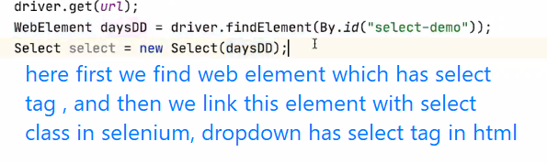

Disabled method not exist In selenium. You use ! method to solve your problems.

* **select_by_index(index)**: Selects the option at the specified index.
* **select_by_value(value)**: Selects the option with the given value attribute.
* **select_by_visible_text(text)**: Selects the option with the visible text matching the provided text.
* **deselect_all()**: Deselects all selected options within the dropdown.
* **deselect_by_index(index)**: Deselects the option at the specified index.
* **deselect_by_value(value)**: Deselects the option with the given value attribute.
* **deselect_by_visible_text(text)**: Deselects the option with the visible text matching the provided text.
* **is_multiple()**: Returns a boolean indicating whether the dropdown allows multiple selections.